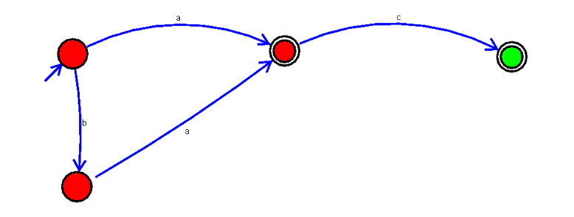
12. Design DFA using simulator to accept the input string “a” ,”ac”,and ”bac”.
- a → q0 → q1 → Accepted
- ac → q0 → q1 → q3 → Accepted
- bac → q0 → q2 → q1 → q3 → Accepted
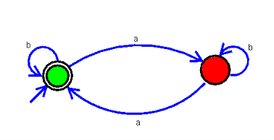
21. Design DFA using simulator to accept even number of a’s.
- bb → 0 a's → Accepted
- bba → 1 a → Rejected
- bbaa → 2 a's → Accepted
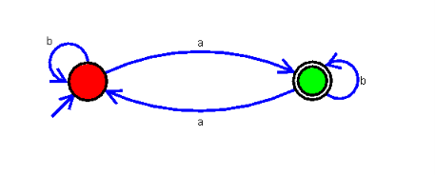
22. Design DFA using simulator to accept odd number of a’s
a → 1 a → Accepted
ba → 1 a → Accepted
aba → 2 as → Rejected
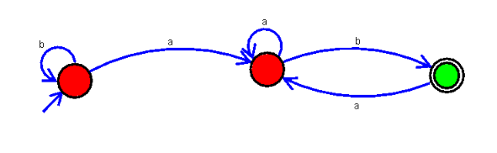
23. Design DFA using simulator to accept the string the end with ab over set {a,b) W= aaabab
aaabab is Accepted
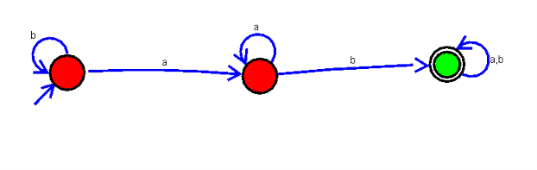
24. Design DFA using simulator to accept the string having ‘ab’ as substring over the set {a,b}
Accpeted states: babb,aaba,abababa,abbab
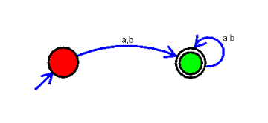
25. Design DFA using simulator to accept the string start with a or b over the set {a,b}
Accepted states: a,b,ab,ba,aba
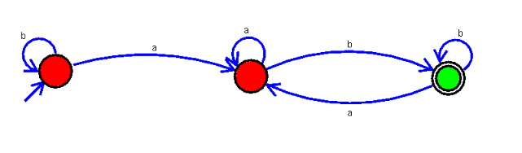
28. Design DFA using simulator to accept the string the end with ab over set {a,b) W= abbaabab
Accepted : abbaabab
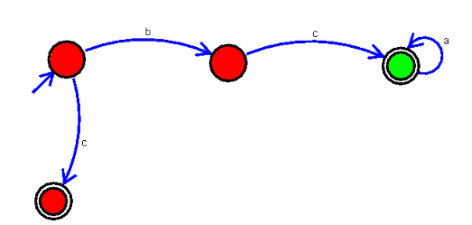
29. Design DFA using simulator to accept the input string “bc” ,”c”,and ”bcaaa”.

Accepted states: c, bc, bcaa

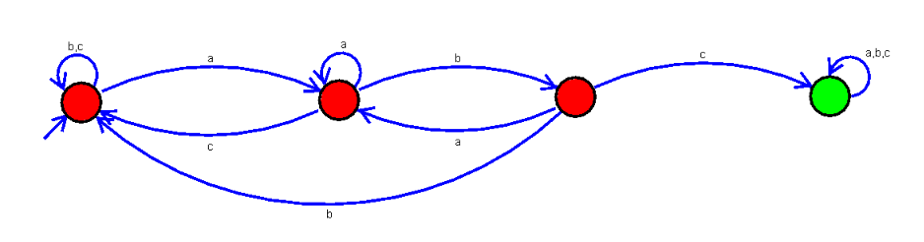
33. Design DFA using simulator to accept the string having ‘abc’ as substring over the set {a,b,c}
Accepted states: baabcca
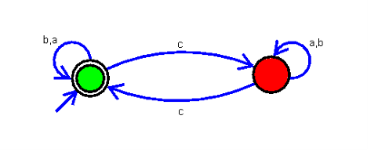
34. Design DFA using simulator to accept even number of c’s over the set {a,b,c}
Accepted states: cc,bcabcacbc
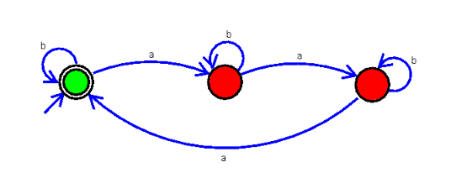
35. Design DFA using simulator to accept strings in which a’s always appear tripled over input {a,b}
Accepted states: baaa,aaab
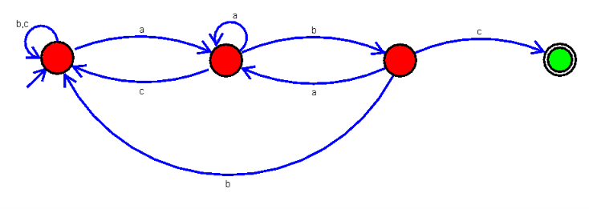
39. Design DFA using simulator to accept the string the end with abc over set {a,b,c) W= abbaababc
NFA
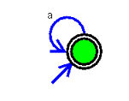
30. Design NFA to accept any number of a’s where input={a,b}.
Accepted states: a,aa,aaa,aaaa
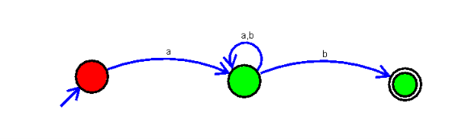
36. Design NFA using simulator to accept the string the start with a and end with b over set {a,b} and check W= abaab is accepted or not.

Accepted state: abaab
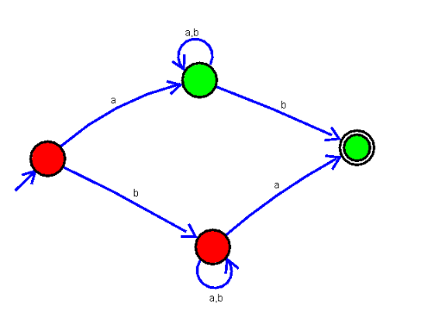
37. Design NFA using simulator to accept the string that start and end with different symbols over the input {a,b}.
Accepted states: ab,ba,abab,abababb
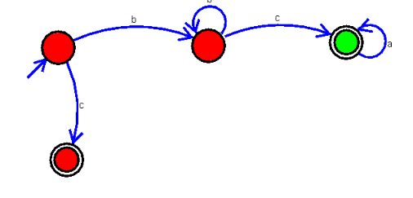
38. Design NFA using simulator to accept the input string “bbc” ,”c”,and ”bcaaa”.
Accepted states: bbc, c, bcaaa
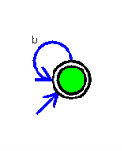
40. Design NFA to accept any number of b’s where input={a,b}.
Accepted states: b,bb,bbb,bbbbbb
13. Design PDA using simulator to accept the input string aabb
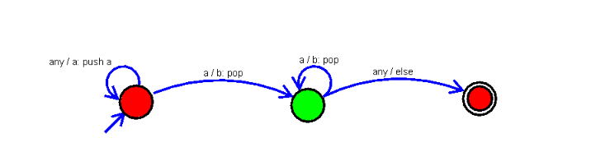
31. Design PDA using simulator to accept the input string anbn

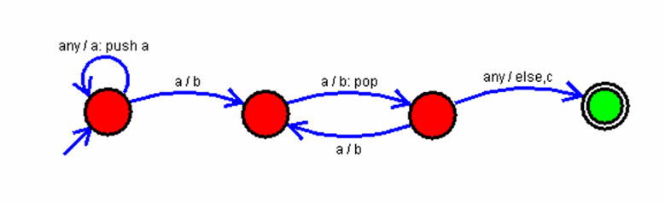
14. Design PDA using simulator to accept the input string anb2n

